**Program 1: Abstraction with YouTube Videos**

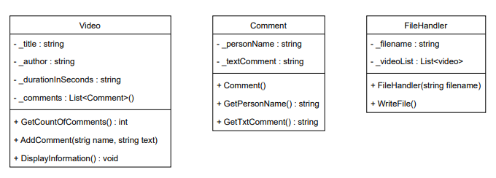

**Description of Class Diagram**

This program allows the creation of videos from the Video class, whose attributes are title, author, duration and comments. It also has methods such as GetCountComments() that returns the number of comments for each video, AddComment() inserts a comment each time this method is invoked in the list of comments, and the DisplayInformation() method that shows all the information of the video in this order: Title, author, duration, number of comments and lists the comments made for each video. Each video can have an indefinite number of comments therefore an attribute called comments was created which is of the Comment class type. The Comment class has two attributes, the name of the person and the comment made on the video. The constructor of the Comment class, establishes the name and comment text of each comment. We will also have a class called FileHandler that will allow to save in a file all the objects created from the Program class through the WriteFile() method.